Name

Mathematics Stage 4
Introduction to Algebra

Book 1 |  | Version: 260930  Feedback:  https://MrDingMaths.com
Contents
Syllabus Content 2
Generalising Relationships using Algebra 5
Algebraic Conventions 8
Parts of an Expression 13
Forming Expressions from Diagrams 18
Forming Expressions from Descriptions 23
Substitution and Evaluation 30
Substitution with Negative Numbers 39
Generating Patterns by Substitution 45

Syllabus Content
MA4-ALG-C-01 generalises number properties to operate with algebraic expressions including expansion and factorisation
Examine the concept of pronumerals as a way of representing numbers
- Examine and recognise that pronumerals can be used to represent one or more numerical values and when pronumerals have more than one numerical value, they may then be referred to as variables
- Identify and define an algebraic expression as an expression formed by combining numbers and algebraic symbols using arithmetic operations
- Use concise algebraic notation and conventions for multiplication, division and powers, and explain the meanings for each convention
Create algebraic expressions and evaluate them by substitution
- Generate algebraic expressions by translating descriptions and vice versa
- Substitute numbers into algebraic expressions and evaluate the result
- Generate a number pattern from an algebraic expression

Generalising Relationships using Algebra

- Algebra
- Algebra communicates patterns, rules, and relationships involving numbers.
- Pronumerals are letters or symbols that represent numbers, such as $x,y$ or $π$.
- Variables are pronumerals with many possible numerical values.

- Generalising
- An algebraic expression combines numbers, pronumerals, and symbols.
- Algebra shows relationships that work for any number, not just one specific example.
- Showing a pattern works for any number is called generalising.

- Example Generalise rules of arithmetic
Look at the pattern and generalise a rule.
$$5×0=0 \\ 6×0=0 \\ 51×0=0 \\ \frac{1}{2}×0=0$$

English expression: Any number times zero is zero

- Guided Practice
Generalise these relationships.
$$4×1=4 \\ 7×1=7 \\ \left(-3\right)×1=-3$$  English  expression: …………………………………  …………………………………  Any number multiplied by 1 is itself.  Algebraic  expression: …………………………………  $n×1=n$ | $$9+9+9=3×9 \\ 2+2+2=3×2 \\ (-4)+(-4)+(-4)=3×(-4)$$  English  expression: …………………………………  …………………………………  Any number added to itself twice is three times the number.  Algebraic  expression: …………………………………  $n+n+n=3×n$

- Key Ideas
- Pronumerals are letters or symbols that represent …………………
- If a pronumeral represents any number, then we call it a ……………………
- Algebra involves using ……………………… to represent numbers so we can quickly communicate mathematical relationships.

Foundation
- Generalise these number facts.
$$6-6=0 \\ 1-1=0 \\ 17-17=0$$  English  expression: Any number subtract by  itself is zero.  Algebraic  expression: ……………………………  $n-n=0$ | $$9+9=2×9 \\ 3+3=2×3 \\ (-4)+(-4)=2×(-4)$$  English  expression: ……………………………  ……………………………  Any number added to itself is two times the number..  Algebraic  expression: ……………………………  $n+n=2×n$
$$\frac{1}{100}=1÷100 \\ \frac{3}{20}=3÷20 \\ \frac{7}{3}=7÷3 \\ \frac{11}{7}=11÷7$$  English  expression: ……………………………  ……………………………  Any fraction is the numerator divided by the denominator  Algebraic  expression: ……………………………  $$\frac{a}{b}=a÷b$$ | $$2+\left(-5\right)=2-5 \\ 4+\left(-1\right)=4-1 \\ 9+\left(-12\right)=9-12 \\ \left(-3\right)+\left(-5\right)=\left(-3\right)-5$$  English  expression: ……………………………  ……………………………  Adding a negative number is the same as subtracting the positive.  Algebraic  expression: ……………………………  $a+\left(-b\right)=a-b$
$$2÷2=1 \\ 8÷8=1 \\ 6÷6=1 \\ 14÷14=1$$  English  expression: ……………………………  ……………………………  Any number divided by itself is 1  Algebraic  expression: ……………………………  $$n÷n=1$$ | $$8÷1=8$$  $$5÷1=5 \\ 12÷1=12 \\ 13÷1=13$$  English  expression: ……………………………  ……………………………  Any number divided by 1 is itself.  Algebraic  expression: ……………………………  $n÷1=n$

$$6-0=6 \\ 1-0=1 \\ 12-0=12 \\ 17-0=17$$  Algebraic  expression:  $n-0=n$ | $$3+4=4+3 \\ 8+6=6+8 \\ 16+7=7+16 \\ \left(-2\right)+8=8+(-2)$$  Algebraic  expression:  $a+b=b+a$
$$2×3=3×2 \\ 4×7=7×4 \\ 111×56=56×111 \\ \left(-2\right)×4=4×(-2)$$  Algebraic  expression:  $a×b=b×a$ | $$2+\left(-2\right)=0 \\ 3+\left(-3\right)=0 \\ 15+\left(-15\right)=0 \\ 8+\left(-8\right)=0$$  Algebraic  expression:  $n+\left(-n\right)=0$
$$2×2=2^{2} \\ 10×10={10}^{2} \\ \left(-3\right)×(-3)={\left(-3\right)}^{2} \\ 24×24={24}^{2}$$  Algebraic  expression:  $n×n=n^{2}$ | $$7÷2=7×\frac{1}{2} \\ 8÷4=8×\frac{1}{4} \\ 11÷\frac{2}{3}=11×\frac{3}{2} \\ 9÷\frac{5}{4}=9×\frac{4}{5}$$  Algebraic  expression:  $$a÷b=a×\frac{1}{b}$$

- Change these English expressions to algebraic expressions.
- Any number add zero equals itself.  $n+0=n$ | - Any number added to itself is the same as multiplying that number by 2.  $n+n=2n$
- Doubling any number twice is the same as multiplying it by 4.  $n×2×2=4n$ | - Multiplying any number by 5 is the same as multiplying it by 10, then dividing by 2.  $n×5=n×10÷2$

Algebraic Conventions

- Apply algebraic conventions to simplify expressions
Leave out × symbol when multiplying. $3×x= 3x$
Write numbers first, then variables. $x×6= 6x$
Hide the 1 when multiplying by 1 or $-1$. $1×x=x$ $-1×x= -x$
- $6×a$  $6a$ | - $t×3$  $3t$ | - $h×z$  $hz$ | - $x×5×y$  $5xy$
- $12×y×x$  $12yx$ | - $-1×y$  $-y$ | - $z×1$  $z$ | - $h×-1×n$  $-hn$

Brackets without an operation in front means multiply. $3×5= 3\left(5\right)$
- $6×8$  $6(8)$ | - $12×4$  $12(4)$ | - $-2×12$  $-2\left(12\right)$ | - $-3×7$  $-3(7)$
- $7×4×5$  $7\left(4\right)\left(5\right)$ | - $12×\left(x-3\right)$  $12\left(x-3\right)$ | - $\left(x-5\right)×-3$  $-3\left(x-5\right)$ | - $-1×\left(x+4\right)$  $-(x+4)$

Indices (powers) show repeated multiplication. $x×x×x →x^{3}$
- $w×w$  $w^{2}$ | - $9×w×w$  $9w^{2}$ | - $z×z×z×z$  $z^{4}$ | - $x×x×w$  $x^{2}w$
- $y×6×y$  $6y^{2}$ | - $y×y×z$  $y^{2}z$ | - $z×y×y$  $zy^{2}$ | - $x×7×x×y$  $7x^{2}y$

Show division using fractions. $x÷3=$ $\frac{x}{3}$
- $a÷7$  $$\frac{a}{7}$$ | - $7÷a$  $$\frac{7}{a}$$ | - $2x÷13$  $$\frac{2x}{13}$$ | - $n÷y$  $$\frac{n}{y}$$

- Algebraic Conventions
Hide the × symbol when multiplying. | $3×x= 3x$
Write numbers before pronumerals. | $x×6= 6x$
Hide 1 when multiplying by 1 or $-1$. | $1×x=x$  $-1×x= -x$
Brackets without an operation means multiply. | $3×5= 3\left(5\right)$
Indices show repeated multiplication. | $x×x×x=x^{3}$
Show division as fractions. | $x÷3=$ $\frac{x}{3}$

- Key Ideas
- Rules of reading and writing algebra are called algebraic ……………….…
- Using algebraic conventions make mathematical expressions ……………………,
so communication is more efficient.

Foundation
- Simplify these expressions by writing them without multiplication signs.
- $4×m$  $4m$ | - $6×t$  $6t$ | - $3×k$  $3k$ | - $10×z$  $10z$
- $p×7$  $7p$ | - $m×5$  $5m$ | - $k×8$  $8k$ | - $n×2$  $2n$
- $w×z$  $wz$ | - $c×v$  $cv$ | - $p×q$  $pq$ | - $a×b$  $ab$
- $t×t$  $t^{2}$ | - $q×q$  $q^{2}$ | - $-1×s$  $-s$ | - $a×b×c$  $abc$
- $2×s×t$  $2st$ | - $6×q×p$  $6qp$ | - $8×p×q×r$  $8pqr$ | - $a×a×c$  $a^{2}c$
- $2×v×v$  $2v^{2}$ | - $5×w×w$  $5w^{2}$ | - $p×p×8$  $8p^{2}$ | - $p×8×p$  $8p^{2}$

- Show the meaning of each algebraic expression by inserting multiplication signs.
- $9w$  $9×w$ | - $5g$  $5×g$ | - $52m$  $52×m$
- $tz$  $t×z$ | - $v^{2}$  $v×v$ | - $3pq$  $3×p×q$
- $8ab$  $8×a×b$ | - $b^{2}$  $b×b$ | - $12mn$  $12×m×n$
- $krz$  $k×r×z$ | - $3abc$  $3×a×b×c$ | - $35hs$  $35×h×s$
- $-y$  $-1×y$ | - $-4xy$  $-4×x×y$ | - $-x^{3}$  $-1×x×x×x$

- Simplify these expressions by writing them as fractions.
- $y÷6$  $$\frac{y}{6}$$ | - $8÷k$  $$\frac{8}{k}$$ | - $6÷w$  $$\frac{6}{w}$$
- $2÷s$  $$\frac{2}{s}$$ | - $9÷t$  $$\frac{9}{t}$$ | - $ab÷3$  $$\frac{ab}{3}$$
- $pq÷7$  $$\frac{pq}{7}$$ | - $3t÷4$  $$\frac{3t}{4}$$ | - $7y÷3$  $$\frac{7y}{3}$$
- $4k÷9$  $$\frac{4k}{9}$$ | - $7tv÷2$  $$\frac{7tv}{2}$$ | - $12xy÷z$  $$\frac{12xy}{z}$$
- $(z+3)÷2$  $$\frac{z+3}{2}$$ | - $(3+x)÷-4$  $$\frac{3+x}{-4}$$ | - $-11÷\left(x+1\right)$  $$\frac{-11}{x+1}$$

- Show the meaning of each expression by rewriting them with division signs.
- $\frac{3}{10}$  $3÷10$ | - $\frac{m}{6}$  $m÷6$ | - $\frac{8}{n}$  $8÷n$
- $\frac{h}{3}$  $h÷3$ | - $\frac{z}{2}$  $z÷2$ | - $\frac{2}{p}$  $2÷p$
- $\frac{pq}{2}$  $pq÷2$ | - $\frac{km}{5}$  $km÷5$ | - $\frac{4}{5t}$  $4÷5t$

- Simplify these expressions using algebraic conventions.
- $4 × m$  $$4m$$ | - $6 × t$  $$6t$$ | - $m × 5$  $$5m$$
- $x × w$  $$xw$$ | - $5 × w × w$  $$5w^{2}$$ | - $4q ×(n+5)$  $$4q(n+5)$$
- $a×3×b$  $$3ab$$ | - $h÷3$  $$\frac{h}{3}$$ | - $3÷h$  $$\frac{3}{h}$$
- $a×b÷3$  $$\frac{ab}{3}$$ | - $7÷(3+y)$  $$\frac{7}{3+y}$$ | - $\left(a+3\right)÷4$  $$\frac{a+3}{4}$$
- $a×b×a×a$  $$a^{3}b$$ | - $c×c÷4$  $$\frac{c^{2}}{4}$$ | - $\left(a-4\right)÷\left(b+9\right)$  $$\frac{a-4}{b+9}$$

- Write the operations to show the difference between these three expressions.
- $2a$  $$2×a$$ | - $\frac{2}{a}$  $$2÷a$$ | - $\frac{a}{2}$  $$a÷2$$
- $a^{2}$  $$a×a$$ | - $2ab$  $$2×a×b$$ | - ${\left(ab\right)}^{2}$  $$ab×ab$$

- Show the meaning of each expression by writing it out in full.
- $9w$  $9×w$ | - $48z$  $48×z$ | - $tz$  $t×z$
- $3abc$  $3×a×b×c$ | - $2w-9$  $2×w-9$ | - $4(k-9m)$  $4×\left(k-9×m\right)$
- $d^{2}$  $d×d$ | - ${3x}^{4}$  $3×x×x×x×x$ | - $3ac^{2}d$  $3×a×c×c×d$
- $\frac{1}{9}$  $1÷9$ | - $\frac{h}{7}$  $h÷7$ | - $\frac{2a}{p}$  $2×a÷p$

Parts of an Expression

- Terms
- A term is part of an expression.
- Terms are separated by addition.
- Terms can be pronumerals, numbers, or a combination.

- Identify terms of an expression
$3a+b+13c$  The terms are: $3a, b, 13c$ |  | $3xy+y-12$  $=3xy+y+(-12)$  The terms are: $3xy,y,(-12)$
Identify the terms of these expressions
Expression | Terms | Expression | Terms
$$3x+9$$ |  | $$9-3x-4y$$
$$3x-9$$ |  | $$9-3a-4b$$
$$3x+4y-9$$ |  | $$3a^{2}$$
$$3x-4y-9$$ |  | $$3a^{2}-4$$
$$3x-4y+9$$ |  | $$3a^{2}-4b+9$$
$$-3x-4y+9$$ |  | $$3a^{2}-4a+9$$

- Key Ideas
- Terms are parts of an algebraic expression that are separated by ………………………
- In algebra, treat subtraction as adding the ………………………
- In the expression $3x-7$, the terms are: ………… and ……………

- Coefficients
- A coefficient is the number multiplying a pronumeral.

- Identify the coefficient of $x$
$$3x$$  Coefficient is $3$ |  | $$\frac{x}{3}$$  Coefficient is $\frac{1}{3}$ |  | $$3-x$$  Coefficient is $-1$
Identify the coefficient of $x.$
- $3x$ | - $5x$ |  | - $13x$ |  | - $2481x$
- $0.5x$ | - $-123x$ |  | - $x$ |  | - $-x$
- $2x+y$ | - $y+2x$ |  | - $y-2x$ |  | - $18-9x$
- $y$ | - $2y$ |  | - $\frac{1}{2}$ $x$ |  | - $\frac{x}{2}$
- $\frac{x}{5}$ | - $\frac{3}{7}$ $x$ |  | - $\frac{3x}{7}$ |  | - $x^{2}+5x$

- Constant Term
- Constant terms are numbers without variables.

- Identify the constant term
$$3x+5$$  Constant is 5 |  | $$-9x+11$$  Constant is 11 |  | $$3x-11$$  Constant is $-11$
Identify the constant term
- $3x+6$ | - $4x+9$ |  | - $12x+7$ |  | - $7+12x$
- $4x+0.5$ | - $4x+$ $\frac{1}{2}$ |  | - $4x-1$ |  | - $4x-48$
- $y+3x+12$ | - $2y-3x+4$ |  | - $2xy-9$ |  | - $9y$

- Parts of an Expression
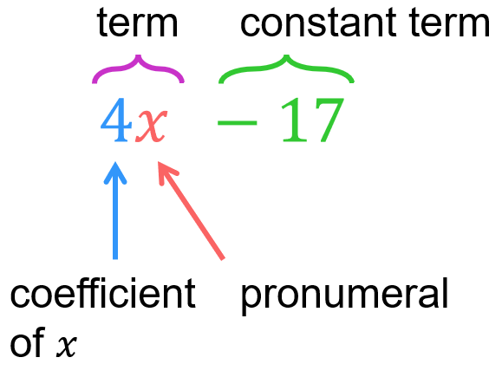

- Example Identify the parts of an algebraic expression
$2x-4y-9$
Terms: $2x, -4y, -9$
Pronumerals: $x$, $y$
Coefficient of $x:$ $2$
Coefficient of $y$: $-4$
Constant term: $-9$

- Guided Practice
- $3x-6y+14$  Terms:  $$3x, -6y, 14$$  Pronumerals:  $$x, y$$  Coefficient of $x:$  $$3$$  Coefficient of $y$:  $$-6$$  Constant term:  $$14$$ | - $-2a+4b+9$  Terms:  $-2a, 4b, 9$  Pronumerals:  $a,b$  Coefficient of $a:$  $-2$  Coefficient of $b$:  $4$  Constant term:  $9$
- $17u+$ $\frac{b}{2}$ $-12$
Terms:
$$17u,\frac{b}{2}, -12$$
Pronumerals:
$u,b$
Coefficient of $u:$
$17$
Coefficient of $b$:
$$\frac{1}{2}$$
Constant term:
$-12$

- Key Ideas
- A constant term is a term that has no ……………………………
- The coefficient is the number that a pronumeral is ………………………… by.

Foundation
- List all the terms in these expressions.
- $3x+2y$  $3x, 2y$ | - $4a+2b+c$  $4a,2b,c$ | - $5a+3b+2$  $5a,3b,2$ | - $2x+5$  $2x,5$

- Identify the constant terms in these expressions.
- $7a+5$  $5$ | - $2x+3y+6$  $6$ | - $8+3x+2y$  $8$ | - $5a+1+3b$  $1$

- For each of the following expressions, state the coefficient of $n$.
- $17n+24$  $17$ | - $31-27a+15n$  $15$ | - $15w+21n+1$  $21$ | - $15a+2n+xy$  $2$
- $n+51$  $1$ | - $21-n$  $-1$ | - $0.5-8n$  $-8$ | - $5-$ $\frac{3n}{4}$  $$-\frac{3}{4}$$

- The expression $4x+3y+24z+7$ has four terms.
- List all the terms.  $4x,3y,24z,7$ | - Identify the constant term.  7 | - Identify the coefficient of $x.$  4 | - Which pronumeral has coefficient 24?  $z$

- Consider the expression $5a+3b-7c+12$
- List all the terms.  $5a,3b,-7c,12$ | - Identify the constant term.  $12$ | - Identify the coefficient of $c$.  $-7$

- Consider expression $3a+b+13c$
- List all the terms.  $3a,b,13c$ | - Identify the constant term.  $0$ | - Identify the coefficient of $b$.  $1$

Development

Expression | Pronumerals | Coefficient of $a$ | Constant Term
$3a+9$ | $a$ | $3$ | 9
$$3a-9$$ | $a$ | $3$ | $-9$
$3b-9$ | $b$ | $3$ | $-9$
$3b$ | $b$ | $3$ | $0$
$3a$ | $a$ | $3$ | $0$
$-9$ | None | $0$ | $-9$
$$2a+3b-9$$ | $a,b$ | $2$ | $-9$
$$2a-3b-9$$ | $a,b$ | $2$ | $-9$
$$2a-3b+9$$ | $a,b$ | $2$ | $9$
$$-2a-3b+9$$ | $a,b$ | $-2$ | $9$
$$9-2a-3b$$ | $a,b$ | $-2$ | $9$
$$a-3b+2$$ | $a,b$ | $1$ | $2$
$$\frac{a}{3}-3b+2$$ | $a,b$ | $$\frac{1}{3}$$ | $2$
$$\frac{2a}{3}-3b+2$$ | $a,b$ | $$\frac{2}{3}$$ | $2$
$$-\frac{4a}{5}+3b+15$$ | $a,b$ | $$-\frac{4}{5}$$ | $15$
$$3b-\frac{3a}{7}-14$$ | $a,b$ | $$-\frac{3}{7}$$ | $-14$
$$3a^{2}+4a+1$$ | $a$ | $4$ | $1$
$$3a^{2}-4a$$ | $a$ | $-4$ | $0$

Forming Expressions from Diagrams

- Algebraic Expressions
- Algebraic expressions communicate relationships involving numbers.
- The pronumeral represents an unknown amount.
- The same pronumeral always represents the same number in one expression.

- Example Represent a concrete scenario as an algebraic expression
Write an algebraic expression for the total number of music discs.
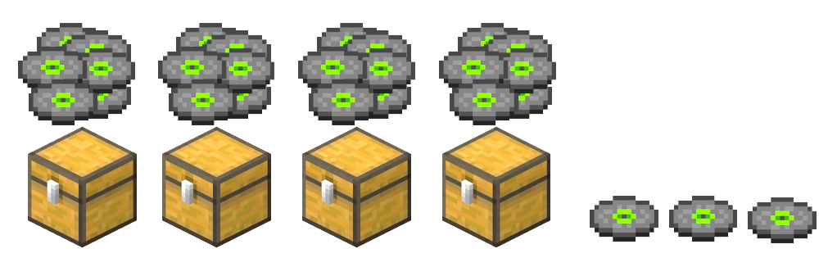  $$4n+3$$ | What does the pronumeral $n$ represent?  $n$ represents the …………… of music discs in each chest.
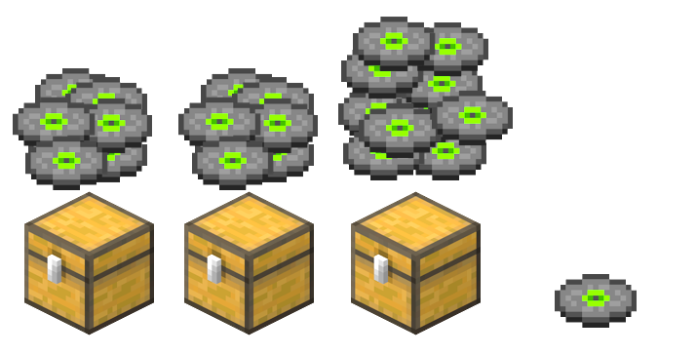  $$2x+y+1$$ | Why did we need two pronumerals,  $x$ and $y$ in this scenario?  One of the chests contains a …………… number of music discs, so we must use a different pronumeral.

- Guided Practice
Represent these scenarios as algebraic expressions
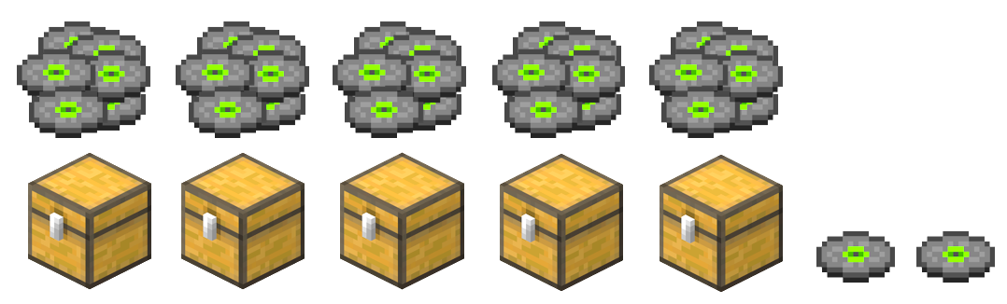  $$5x+2$$ | 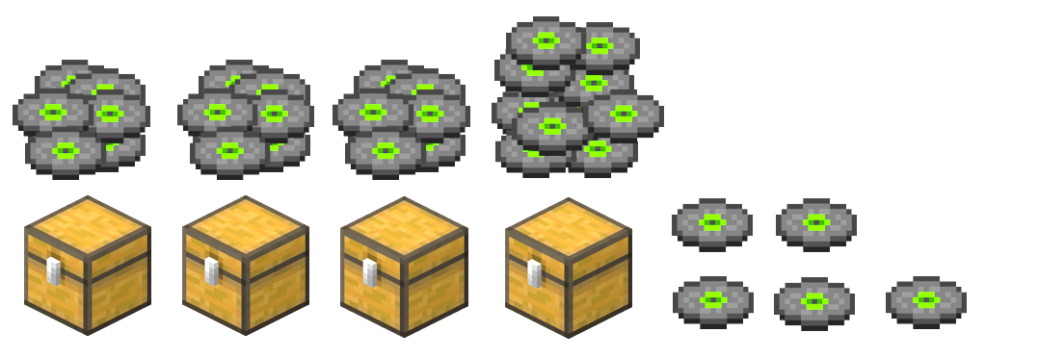  $$3x+y+5$$
$c+2t$ | 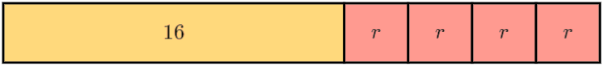  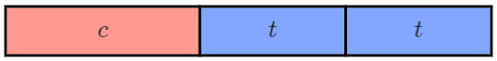  $16+4r$
$6+3a+b$ | 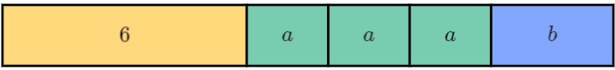  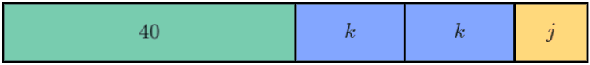  $40+2k+j$

Foundation
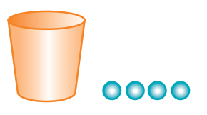
- The diagram shows 1 cup and 4 marbles.

  - If the cup has 6 marbles, total marbles = 6 + 4 = ……
$6+4=10$
  - If the cup has 20 marbles, total marbles = …… + …… = ……
$20+4=24$
  - If the cup has $n$ marbles, total marbles = …………
$n+4$
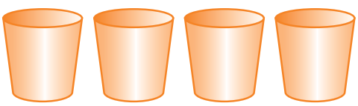
- The diagram shows 4 cups.

  - If each cup has 5 marbles, total marbles = 4 × … = ……
$4×5=20$
  - If each cup has 8 marbles, total marbles = = 4 × … = ……
$4×8=32$
  - If each cup has $n$ marbles, total marbles = 4 × … = ……
$4×n=4n$
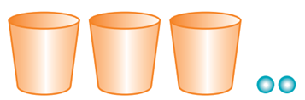
- The diagram shows 3 cups and 2 marbles.

  - If each cup has 5 marbles, total marbles = 3 × …… + 2 = ………
$3×5+2=17$
  - If each cup has 10 marbles, total marbles = 3 × …… + 2 = ………
$3×10+2=32$
  - If each cup has $n$ marbles, total marbles = = 3 × …… + 2 = ………
$3×n+2=3n+2$

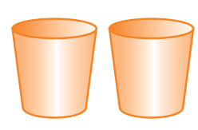
- These two cups have a different number of marbles in them.
Explain why the total number of marbles is NOT $2n$

$2n$ means the two cups have the same number of marbles.

- There are $n$ marbles in each cup.
Write an algebraic expression for the total number of marbles in each diagram.
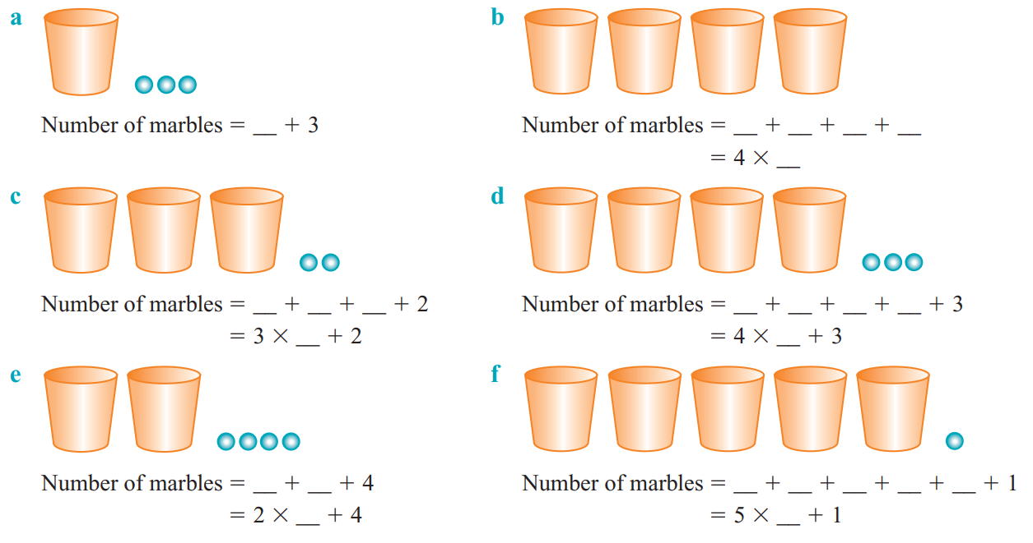  Total marbles $=$ …… $+ 3$  $n+3$ | Total marbles $=$ $4×$ ……… = …………  $4×n=4n$
$3n+2$ | $4n+3$
$2n+4$ | $5n+1$


- There are $x$ biscuits in each packet. Write an expression for the total number of biscuits.

$$2x+3$$
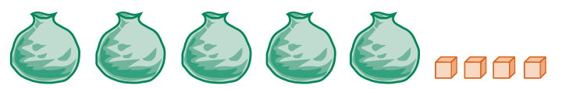
- There are $x$ blocks in each bag. Write an expression for the total number of blocks.

$5x+4$

Issy says:
the total number of blocks is $5x+4$, which is the same as $9x$.

Explain why she is incorrect.

There are not 9 bags of blocks.
- $x$ represents the number of marbles in a cup. Draw a diagram to represent:
- $4x+2$ | - $7x+5$

Development

- Each cup contains $x$ pills. Each bottle contains $y$ pills.
Write the total number of pills in each scenario.
$x+y$ | $x+2y$
$x+2y+2$ | 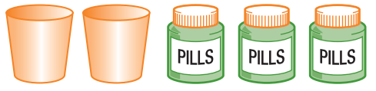  $3y$
$3+x+2y$ | $2x+3y+1$
- Draw $x+y+5$ | - Draw $5x+2y+2$
- Draw $x+3y$ | - Draw $3x+2y+4$

- What expressions are represented by the question marks? Match the answers.
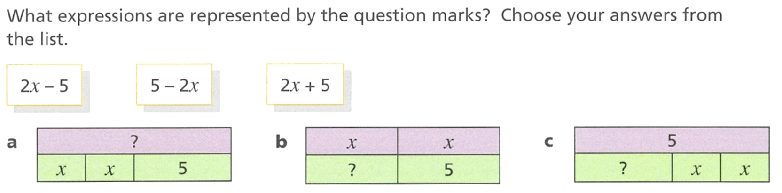

$$a:2x+5, b:2x-5, c:5-2x$$

- What expression is shown by the question mark in these bar models?
$5n$ | 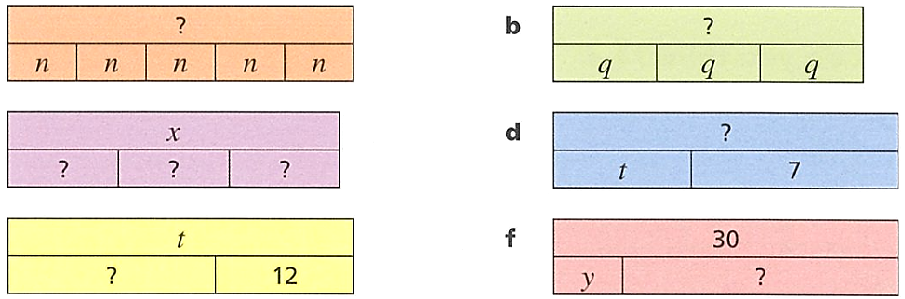  $3q$
$3x$ | $t+7$
$t-12$ | $30-y$
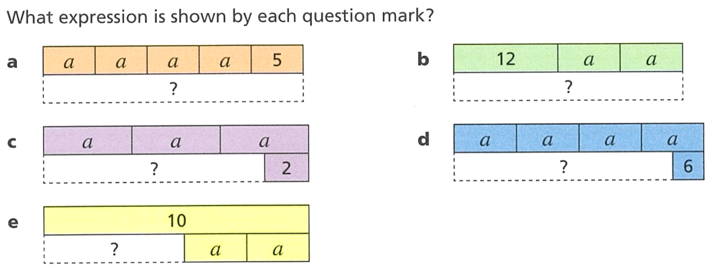  $4a+5$ | $2a+12$
$3a-2$ | $4a-6$

- Draw bar models to represent these expressions.
- $b+4$ | - $b-4$
- $\frac{b}{4}$ | - $4b$

Forming Expressions from Descriptions

- The Language of Operations
Addition: combining two or more amounts.  - Sum  - Total  - More than  - Increased by  1  - Combined | Subtraction: removing an amount.  - Difference between  - Less than  - Decreased by  1
Multiplication: combining equal groups.  - Each  - Per  - Product  - Lots of  - Double $(×2)$,  - Triple $\left(×3\right)$,  - Quadruple… | Division: Splitting into equal groups.  - Each  - Per  - Divided by  - Shared between  - Quotient  - Out of  - Halve $(÷2)$,  - Third $(÷3)$,  - Quarter…
We often swap number order when we see "than" or "from"
“9 subtracted from 7” $7-9$
“12 less than 8” $8-12$

- Write algebraic expressions from a description
Sum of 5 and $a$  $$5+a$$ | Product of $a$ and $b$  $$ab$$ | 3 less than $a$  $$a-3$$
Represent these as an algebraic expression.
- 7 less than $a$ | - $a$ divided by 5 | - $b$ less than $a$
- 14 shared between $n$ | - Product of $x$ and 2 | - $n$ subtracted from 11
- Double $n$, then add 7 | - Product of $x$ and 2,  then divided by $y$ | - $n$ subtracted from 11, then multiplied by 3

Foundation
- Write an expression for each of the following.
- The sum of 3 and 5 is ……+ ……  $3+5$  the sum of $p$ and $q$ is …… + ……  $p+q$ | - 5 groups of 3 is …… $×$ ……  $5×3$  5 groups of $x$ is …… $×$……  $5×x$
- The product of 2 and 6 is ……× ……  $2×6$  the product of $k$ and $m$ is ……× ……  $k×m$ | - 5 more than 4 is ……+ ……  $5+4$  5 more than $w$ is ……+ ……  $5+w$
- 2 less than $8$ is ……− ……  $8-2$  2 less than $c$ is ……− ……  $c-2$ | - 9 squared is ……  $9^{2}$  $k$ squared is ……  $k^{2}$
- Double 7 is ……  $2×7$  Double $a$ is ……  $2a$ | - Half of 10 is ……  $$\frac{10}{2}$$  Half of $b$ is ……  $$\frac{b}{2}$$
- A third of 6 is ……  $$\frac{6}{3}$$  A third of $g$ is ……  $$\frac{g}{3}$$ | - A quarter of 12 is ……  $$\frac{12}{4}$$  A quarter of $h$ is ……  $$\frac{h}{4}$$

- Write an algebraic expression for each of the following.
- The sum of 2 and $x$  $2+x$ | - The sum of $ab$ and $y$  $ab+y$ | - 5 less than $x$  $x-5$
- The product of $x$ and 3  $3x$ | - One quarter of $n$  $$\frac{n}{4}$$ | - Half of $s$  $$\frac{s}{2}$$
- The product of $n$ and $9$  $$9n$$ | - $y$ shared between 8  $$\frac{y}{8}$$ | - $t$ subtracted from 10  $10-t$

- Write an algebraic expression for each of the following.
- 5 is added to $x$,  then the result is doubled.  $2(5+x)$ | - $a$ is tripled,  then 4 is added.  $$3a+4$$ | - 3 more than half of $n$  $$\frac{n}{2}+3$$
- 6 more than double $n$  $2n+6$ | - The square of  the sum of $m$ and $n$  $${\left(m+n\right)}^{2}$$ | - The sum of $x$ and $y$ is multiplied by 6.  $$6(x+y)$$
- $k$ is multiplied by 8, then 3 is subtracted.  $8k-3$ | - The cube of  the sum of $m$ and $n$  $${\left(m+n\right)}^{3}$$ | - The sum of $x$ and $y$  is divided by 5  $$\frac{x+y}{5}$$
- $x$ is multiplied by 7  and the result is halved.  $$\frac{7x}{2}$$ | - $k$ is multiplied by 8,  then 3 is subtracted.  $$8k-3$$ | - 10 less than  the product of 4 and $x$  $$4x-10$$
- The square root of  the sum of $x$ and $y$  $$\sqrt{x+y}$$ | - The product of $x$ and $y$  is subtracted from 12.  $$12-xy$$ | - 3 is subtracted from $k$,  then the result is multiplied by 8.  $$8\left(k-3\right)$$

- Write an expression for each of the following.
- 7 more than $x$  $$x+7$$ | - $x$ more than $y$  $$y+x$$
- 7 less than $x$  $$x-7$$ | - $x$ multiplied by $y$  $$xy$$
- 9 less than $x$  $$x-9$$ | - $x$ divided by $y$  $$\frac{x}{y}$$
- 9 lots of$x$  $$9x$$ | - $x$ divided by 3  $$\frac{x}{3}$$
- 19 lots of $x$  $$19x$$ | - $x$ divided by 3 and then add 2  $$\frac{x}{3}+2$$
- $x$divided by 19  $$\frac{x}{19}$$ | - $x$ divided by 3 and then subtract 2  $$\frac{x}{3}-2$$
- $x$ shared between 19  $$\frac{x}{19}$$ | - $x$ lots of 3 and then subtract 2  $$3x-2$$
- $x$ less than 19  $$19-x$$ | - $x$ lots of 3 and then squared  $${\left(3x\right)}^{2}$$
- $x$ less than 3  $$3-x$$ | - $x$ lots of 3 squared  $$3^{2}x$$
- $x$ less than y  $$y-x$$ | - $x$ squared and then multiply by 3  $$3x^{2}$$

Development
- Write the calculation in numbers, then write the expression in algebra.
Using Numbers | Using Algebra
Becky begins a game with 12 marbles. She wins 3 and loses 5. How many marbles does she have at the end of the game?  $$12+3-5$$ | Becky begins a game with $x$ marbles. She wins $y$ and loses $z$. How many marbles does she have at the end of the game?  $$x+y-z$$
In a class of $30$ children, $10$ have a sister. How many children don’t have a sister?  $30-10$ | In a class of $a$ children,$b$ have a sister. How many children don’t have a sister?  $a-b$
There were $30$ questions in a test. Megan got $25$ correct. How many did she get wrong?  $30-25$ | There were $x$ questions in a test. Megan got $y$ correct. How many did she get wrong?  $x-y$
Lucy went on a journey, going $25$ kilometres by train, $4$ kilometres by bus, and $2$ kilometres on foot. What is the total distance she travelled?  $25+4+2$ | Lucy went on a journey, going $x$ kilometres by train, $y$ kilometres by bus, and $z$ kilometres on foot. What is the total distance she travelled?  $x+y+z$
Mark buys $7$ chocolate bars, each costing $3$ dollars. How much does he spend in total?  $7×3$ | Mark buys $a$ chocolate bars, each costing $b$ dollars. How much does he spend in total?  $ab$
Maddie has $5$ cards. Emma has $2$ times as many as Maddie. How many cards does Emma have?  $5×2$ | Maddie has $a$ cards. Emma has $b$ times as many as Maddie. How many cards does Emma have?  $ab$

- Write an expression for each of the following:
- There are 12 people on a bus.  $x$ get off.  How many people remain?  $12-x$ | - A train has 88 passengers.  $y$ people get on.  How many are on the train?  $88+y$
- A can of lemonade costs $c$ dollars.  How much do 5 cans of lemonade cost?  $5c$ | - Each ice block is $3.  Each lolly bag is $2  How much money is earned from selling $x$ ice blocks and $y$ lolly bags?  $3x+2y$
- A rope is $x$ metres long.  I cut off four lengths of $y$ metres each. How much rope remains?  $x-4y$ | - $n$ students go on an excursion.  How much should Ms Ali charge each student if she wants to share the bus hire fee of $200?  $$\frac{200}{n}$$

- Nicholas buys 10 lolly bags from a supermarket.
- If there are 7 lollies in each bag,  how many lollies does he buy in total?  $7×10=70$ | - If there are $n$ lollies in each bag,  how many lollies does he buy in total?  $10n$

- Write an algebraic expression for the cost of:
- $x$ pies at $6 each.  $6x$ | - $6$ pies at $$x$ each.  $6x$
- 10 pies at $\$n$ each.  $10n$ | - $y$ drinks at $\$2$ each.  $2y$
- $x$ pies at $5 and $y$ drinks at $2  $5x+2y$ | - $x$ pies at $2 and $y$ drinks at $6  $2x+6y$

- The cost of 10 cans of drink is $$x$. Write an expression for:
- The cost of one can of drink  $$\frac{x}{10}$$ | - The cost of $n$ cans  $$\frac{nx}{10}$$

- If pencils cost $\$x$ each, write an expression for the cost of:
- 10 pencils  $10x$ | - $k$ pencils  $kx$ | - 3 packets of pencils,  if each packet contains 5 pencils  $15x$

- Recall that there are 100 centimetres in 1 metre and 1000 metres in 1 kilometre.
Write expressions for each of the following.
- How many metres are there in $x$ km?  $1000x$ | - How many centimetres are there in $x$ metres?  $100x$ | - How many centimetres are there in $x$ km?  $100 000x$

  - Ed is 12 years old. How old will he be in 2 years' time?
$12+2=14$
  - Faith is $y$ years old. How old will she be:
- in 2 years' time  $y+2$ | - in $x$ years' time?  $y+x$ | - 5 years ago?  $y-5$

- A rectangular garden bed is 12 m long and 5 m wide.
  - Find the area of the garden bed. Show your working out.
60 m²
  - The length is increased by $x$ cm and the width are decreased by $y$ cm.
Find the new length and width of the garden.
length: $12+x$
width: $5-y$
  - Write an expression for the area of the new garden bed.

$$\left(12+x\right)\left(5-y\right)$$
- Mikayla is paid $$x$ per hour at her job. Write an expression for each of the following:
  - How much does Mikayla earn if she works 8 hours?
$8x$
  - Mikayla gets a pay rise of $3 per hour, what is her new hourly wage?
$$x+3$$
  - Mikayla works 8 hours at the increased hourly rate, write how much she earns as an expression.
$8\left(x+3\right)$

Mastery
- Match up each sentence to its algebraic expression.
Multiply $b$ by 2 then subtract from $a$ |  |  | $$a(b-c)$$
Subtract $c$ from $a$ then multiply by $b$ |  |  | $$4a-c$$
Multiply $a$ by $b$ then divide by $c$ |  |  | $$\frac{c}{a+b}$$
Add $b$ to $a$ then divide into $c$ |  |  | $$\frac{ab}{c}$$
Divide $c$ by $b$ then multiply by $a$ |  |  | $$abc$$
Multiply $a$ by $c$ then divide into $b$ |  |  | $$b(a-c)$$
Add $b$ to $a$ then divide by $c$ |  |  | $$a-2b$$
Multiply $ab$ by $c$ |  |  | $$\frac{b}{ac}$$
Multiply $a$ by $4$ then subtract $c$ |  |  | $$\frac{a+b}{c}$$
Subtract $c$ from $b$ then multiply by $a$ |  |  | $$\frac{ac}{b}$$

a – G,
b – F,
c – D,
d – C,
e – J,
f – H,
g – I,
h – E,
i – B,
j – A

Substitution and Evaluation

- Substitution and Evaluation
- To substitute means to replace pronumerals with numbers.
- To evaluate means to work out the final number by following the order of operations.

- Example Substitute and evaluate expressions
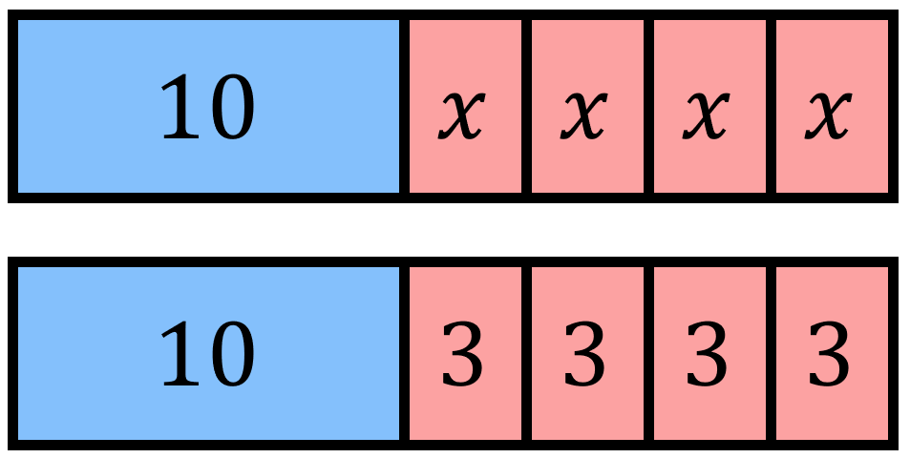
The bar model shows $10+4x$. Evaluate the expression when $x=3$.
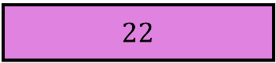
$10+4x$
$$=10+4(3)$$
$$=10+12$$
$$=22$$

- Guided Practice
- The total number of oranges is $x+1$  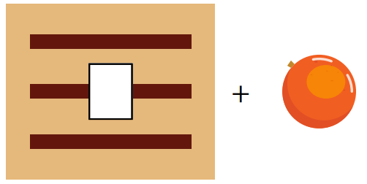  Evaluate the expression for $x=5$  $x +1$  $=$ … $+ 1$  $=$ ………  6 | - The number of Lego pieces is $2x+3$  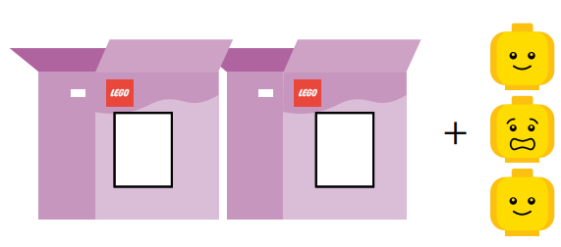  Evaluate the expression for $x=6$  $2x+3$  $=$ …………  $=$ …………  15
- Evaluate $7+5b$ when $b=5$  32 | - Evaluate $\frac{x}{2}$ $+5$ when $x=12$  11
- Evaluate $\frac{n+7}{3}$ when $n=8$  5 | - Evaluate $7-4x$ when $x=2$  $$-1$$

- Key Ideas
- Substitution means to ………………………… a letter with a number.
- ………………… means to calculate the numerical value of an expression.
- When evaluating, always follow the ………………… …… ………………………

Foundation

- The diagram shows $2t+12$ tennis balls.  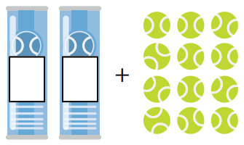  Evaluate when $t=6$.  $2t+12$  $=2\left( \right)+12$  $=$ ………………  24 | - The diagram shows $3c+4$ coins.  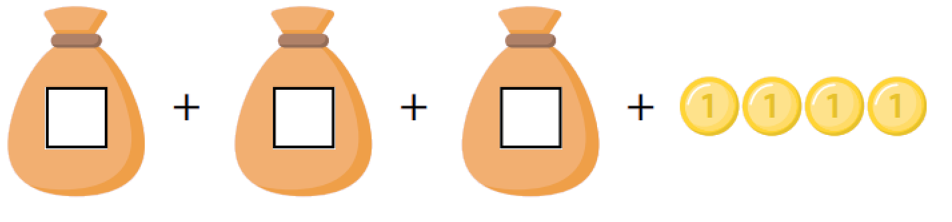  Evaluate when $c=10$.  $3c+4$  $=3\left( \right)+4$  $=$ ………………  34
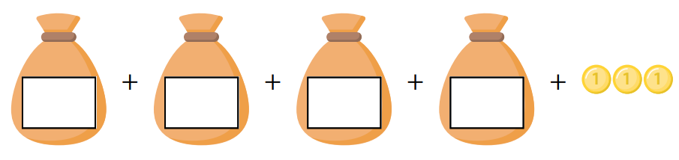  - The diagram shows $4x+3$ coins.  How many coins are there if $x=12$?  51 | 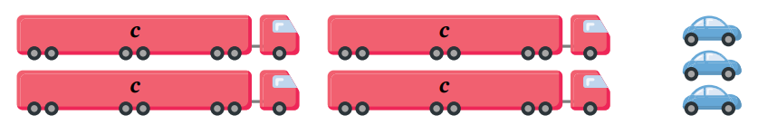  - The diagram shows $2c+3$ cars.  How many cars are there if $c=6?$  15

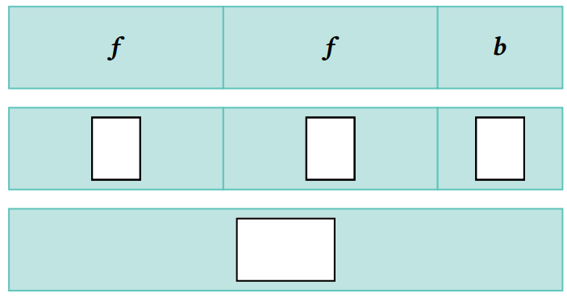
- The bar model shows $2f+b$. Evaluate when $f=7$, $b=3$
$2f+b$
$=2\left( \right)+( )$
$=$ …………………
17

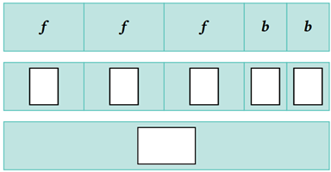
- The bar model shows $3f+2b$. Evaluate when $f=7$, $b=3$
$3f+2b$
$=3\left( \right)+2( )$
$=$ …………………
27

- Substitute $c=5$ to evaluate each expression.
15 | 15 | 50 | 0.5 | 2

- Substitute $x=5$ into these expressions and evaluate the result. Show the substitution step.
a $x+3$  $=\left(5\right)+3$  $=$ …………  8 | b $14-x$  9 | c $2x$  10
d $2x+4$  14 | e $13-2x$  3 | f $3x-6$  9
d $10x$  50 | e $10+x$  15 | f $\frac{x}{10}$  $$\frac{1}{2}$$
d $x-10$  $$-5$$ | e $10-x$  5 | f $x^{2}$  25

- Evaluate these expressions for $g=400$.
$$40$$ | $$\frac{1}{40}$$ | $$4$$ | $$\frac{1}{4}$$ | $$20$$ | 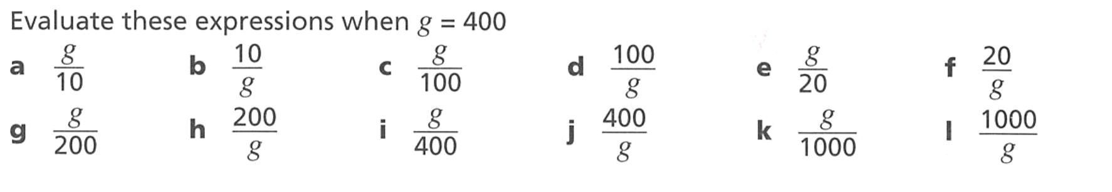  $$\frac{1}{20}$$
$$2$$ | $$\frac{1}{2}$$ | $$1$$ | $$1$$ | $$\frac{2}{5}$$ | $$\frac{5}{2}$$

Development
- Work out the value of each of these expressions when $a=5$
$$53$$ | $$5$$ | $$47$$ | 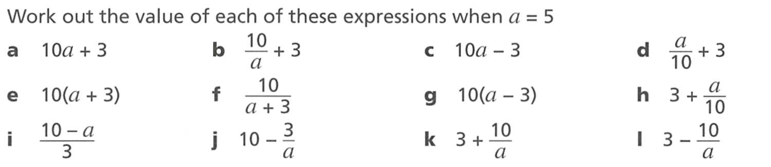  $$3.5$$
$$80$$ | $$\frac{5}{4}$$ | $$20$$ | $$3.5$$
$$\frac{5}{3}$$ | $$\frac{47}{5}$$ | $$5$$ | $$1$$

- If $c=3$, evaluate these expressions.
- $4+c$  7 | - $\frac{5c-7}{2}$  4
- $4c$  12 | - $\frac{4c}{4}$  3
- $4c+c$  15 | - $\frac{c}{4c}$  $$\frac{1}{4}$$
- $5c$  15 | - $c^{2}$  $9$
- $5c-7$  8 | - $2c^{2}$  $$18$$
- $\left(5c-7\right)÷2$  4 | - ${\left(2c\right)}^{2}$  $$36$$
- $5c-7÷2$  11.5 | - $\frac{4c}{4}$  $$3$$

- Evaluate these expressions when $g=80$.
13 | 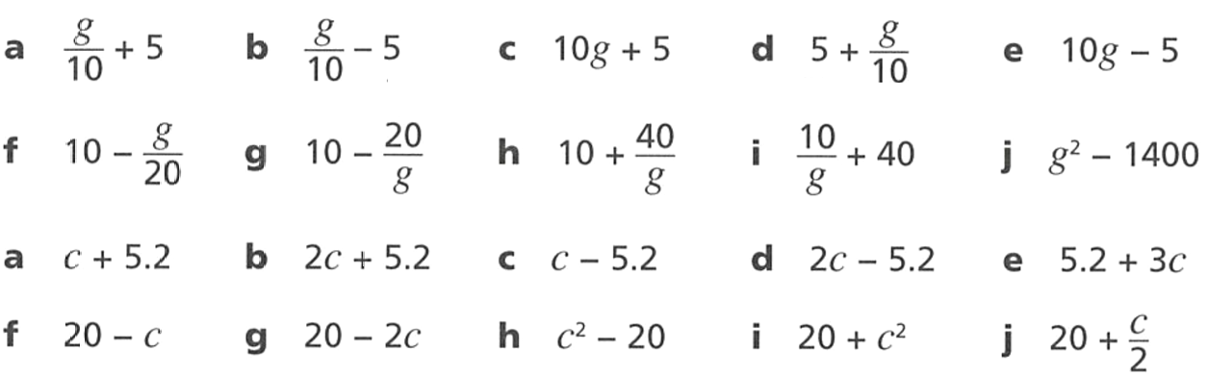  3 | 805 | 13 | 795
6 | $$9\frac{3}{4}$$ | 10.5 | $$40\frac{1}{8}$$ | 5000

- Find the values of each of these expressions when $c=100$
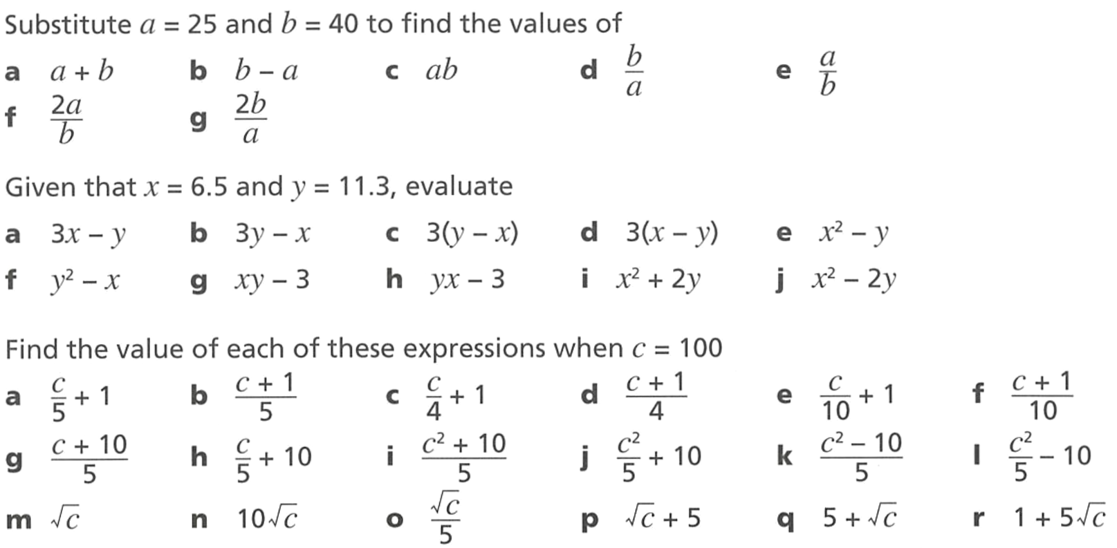  21 | $$\frac{101}{5}$$ | 26 | $$\frac{101}{4}$$ | 11 | $$\frac{101}{10}$$
22 | 30 | 2002 | 2010 | 1998 | 1990
10 | 100 | 2 | 15 | 15 | 51

- Work out the value of each of these expressions when $x=3$ and $y=0$
3 | 3 | 3 | 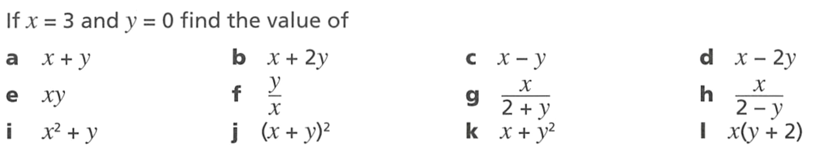  3
0 | 0 | 1.5 | 1.5
9 | 9 | 3 | 6

Mastery
- If $m=9$ and $n=16$, find the values of:
7 | 5 | 36 | 48 | 12

- $x$ and $y$ are two numbers, where $xy = 24$.
  - What values could $x$ and $y$ equal if they are whole numbers?
Try to list as many as possible.

  - What values could $x$ and $y$ be if they can be decimals, fractions, or whole numbers?

- Write two different expressions involving $x$ that evaluate to $-10$ if $x=-5$.

  - Find the difference between $4a+3$ and $4(a+3)$ when $a=2$

  - Find the difference between $4a+3$ and $4(a+3)$ when $a=10$

  - Find the difference between $4a+3$ and $4(a+3)$ when $a=100$

  - Find the difference between $4a+3$ and $4(a+3)$ when $a=0.2$

  - What do you notice?
  - Without any calculations, find the difference between $4a+3$ and $4(a+3)$
when $a=786.174$

9

- Complete the table.
$$a$$ | 10 | 0 | 2 | 12 | 5 | 1
$$a+2$$ | 12 | 2 | 4 | 14 | 7 | 3
$$2a$$ | 20 | 0 | 4 | 24 | 10 | 2
$$a^{2}$$ | 100 | 0 | 4 | 144 | 25 | 1
$$2-a$$ | $-8$ | 2 | 0 | $$-10$$ | $-3$ | 1
$$\frac{a}{2}$$ | 5 | 0 | 1 | 6 | $$\frac{5}{2}$$ | 0.5

- Complete the table.
$$x$$ | 5 | 10 | 7 | 9 | 5 | 8 | 6
$$y$$ | 3 | 4 | 2 | 5 | 2 | 0 | $-6$
$$x+y$$ | 8 | 14 | 9 | 14 | 7 | 8 | 0
$$x-y$$ | $2$ | 6 | 5 | 4 | 3 | 8 | 12
$$xy$$ | 15 | 40 | 14 | 45 | 10 | 0 | $-36$

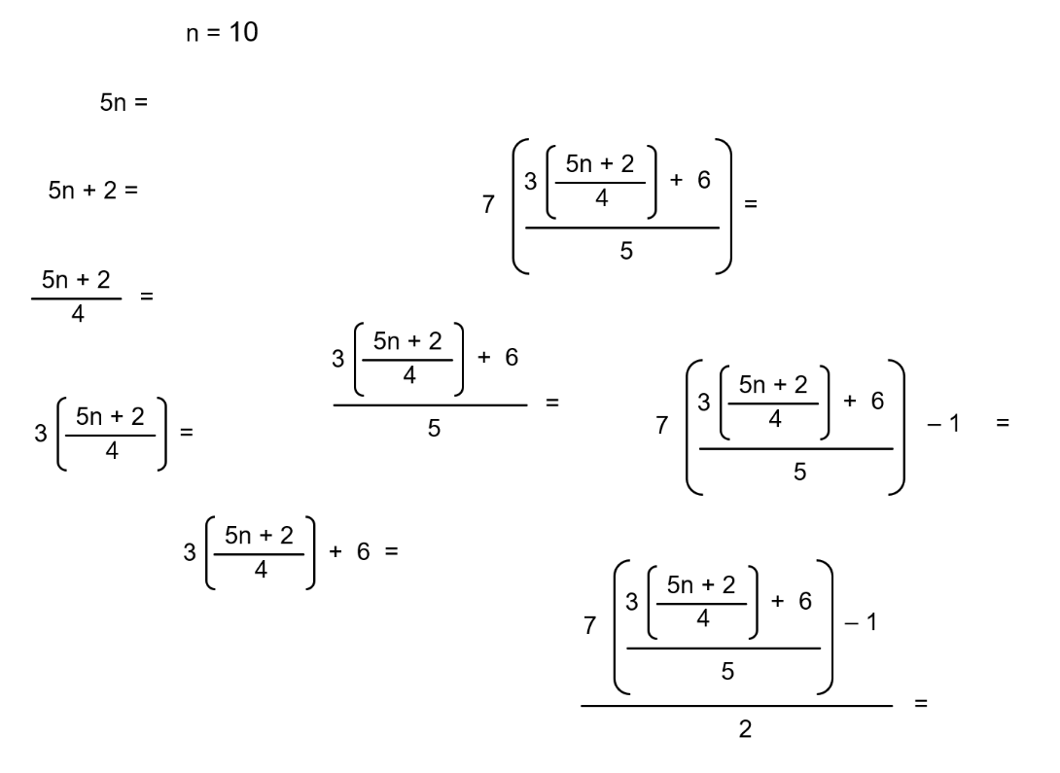
- Evaluate each expression for $n=10$.

31
- Substitute $n=8$ into each expression and evaluate the result.
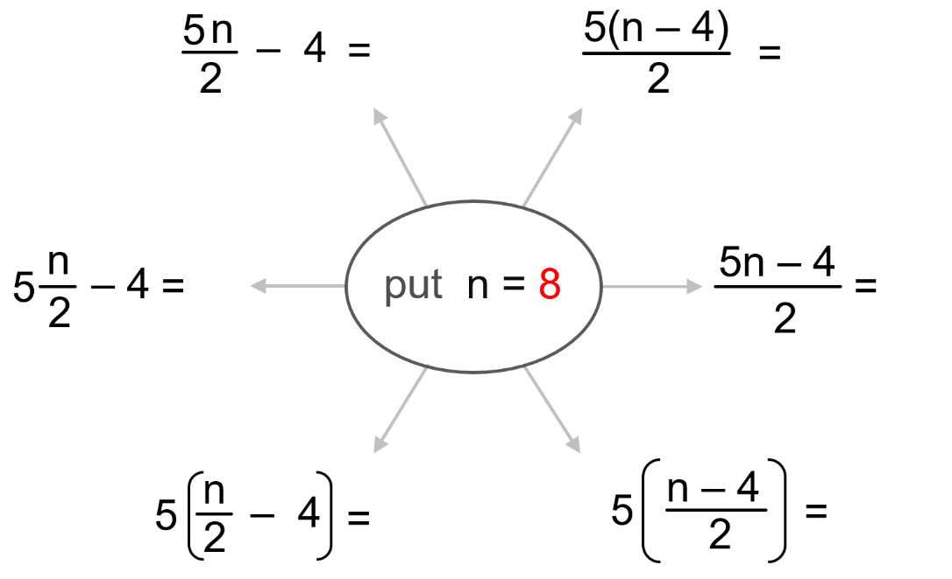

Which of the expressions are equivalent?
$$\frac{5n}{2}-4 and 5\frac{n}{2}-4,$$
$$\frac{5\left(n-4\right)}{2} and 5\left(\frac{n-4}{2}\right)$$
- NAPLAN B
Evaluate the expression $x^{2}+3x-4$ when $x=3$

14
- $R=2d-3e-4f$ Find the value of $R$ if $d=2, e=3, f=$ $\frac{1}{2}$

$-7$
- Evaluate $\frac{20}{y}$ $+ 3x$ when $x=$ $\frac{1}{5}$, $y=2$

$$10\frac{3}{5}$$
- Evaluate $\frac{20}{x}$ $+ 3y$when $x=$ $\frac{1}{5}$, $y=2$

106
- Evaluate the expressions for the given value of $n$
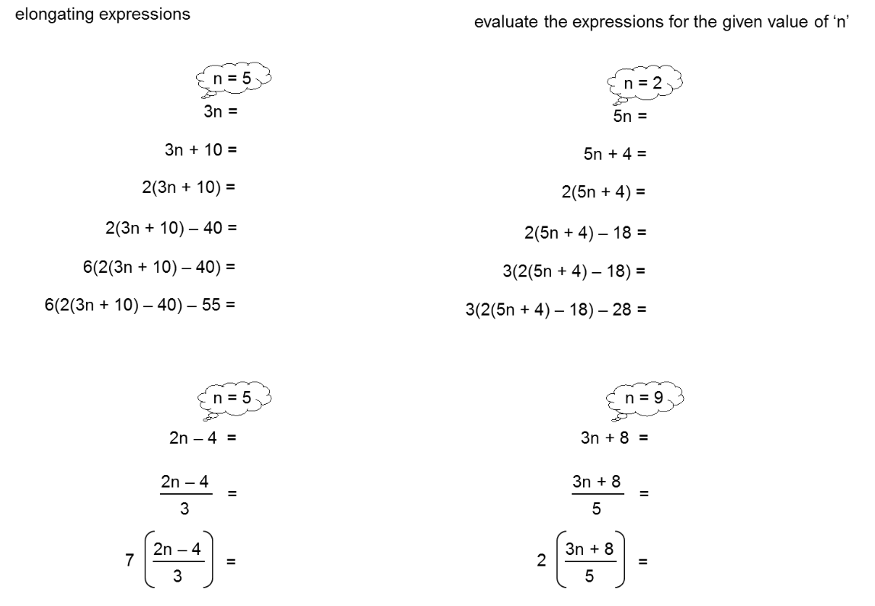  5 | 2
14 | 14

- Find the value of $n$ by working backwards.
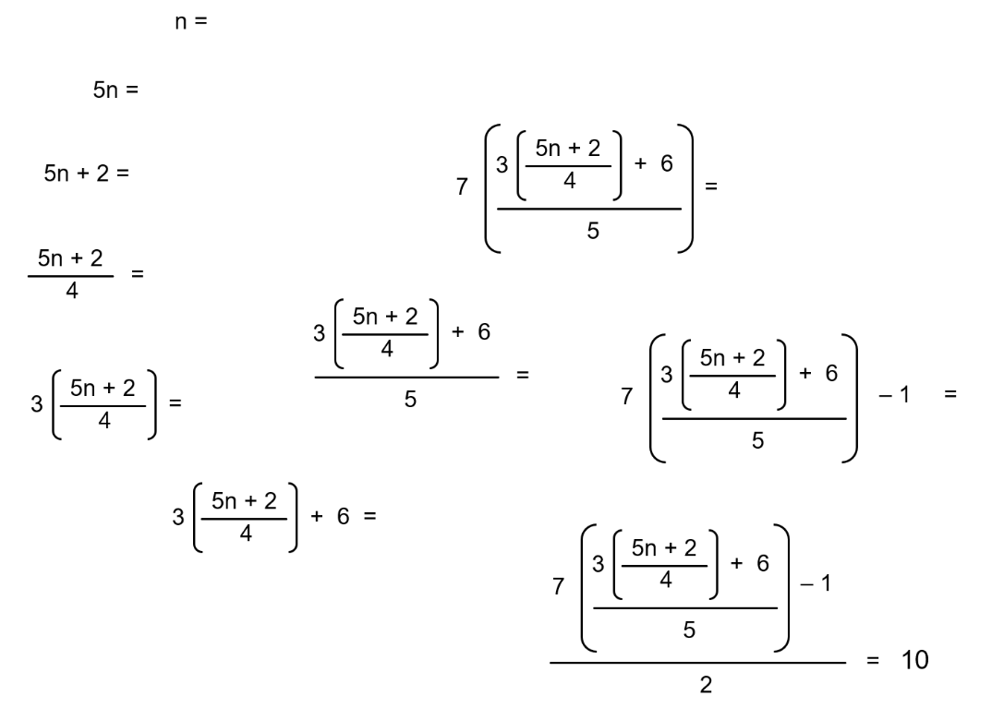

$$n=2$$

Substitution with Negative Numbers

- Substituting Negative Numbers
- Always put brackets around negative numbers when substituting.
- Without brackets, we might mistake a negative sign for subtraction.
- Brackets help calculators follow the order of operations, especially when raising negative numbers to a power.

- Example Evaluate expressions after substituting negative integers
Evaluate:
$10+4b$ for $b=-2$  $10+4b$  $=10+4(-2)$  $=10+(-8)$  $=2$ | $12-3b$ for $b=-5$  $12-3b$  $=12-3(-5)$  $=12-(-15)$  $=27$ | $2b^{2}$ for $b=-3$  $2b^{2}$  $=2{\left(-3\right)}^{2}$  $=2\left(9\right)$  $=18$

- Guided Practice
- Evaluate $x+1$ for $x=-5$  $x +1$  $=$ …… $+ 1$  $=$ ………  $$-4$$ | - Evaluate $2x+3$ for $x=-3$  $2x+3$  $=$ …………  $=$ …………  $$-3$$
- Evaluate $4b^{2}$ for$b=-3$  $$36$$ | - Evaluate $4-x$ for $x=-3$  $$7$$
- Evaluate $\frac{2x+7}{3}$ for $x=-4$  $$-\frac{1}{3}$$ | - Evaluate $12-3b$ for $b=-5$  $$27$$

- Key Ideas
- Always substitute negative numbers in ………………… so you are less likely to make a mistake.

Foundation
- For $x=-5$, evaluate these expressions.
a $x+3$  $=\left(-5\right)+3$  $=$ …………  $-2$ | b $14-x$  $19$ | c $2x$  $-10$
d $2x+4$  $-6$ | e $13-2x$  $23$ | f $3x-6$  $-21$
d $\frac{5x}{7}$  $$-\frac{25}{7}$$ | e $-3x+15$  $30$ | f $10x-50$  $-100$

- For $a=6$ and $b=-2$, evaluate these expressions.
a $a+b$  $4$ | b $a-b$  $8$ | c $b-a$  $-8$
d $2a+b$  $10$ | e $5b+2a$  $2$ | f $6b-7a$  $-54$

- Flo is working out the value of $c-d$. She is told that $c=4$ and $d=-9$. She writes:
$c-d$
$=4-9$
$=-5$
Explain why she is wrong.

She substituted 9, not $-9$
Provide the correct answer.

13

Development
- If $m=-4$ and $n=20$, find the value of:
5 | 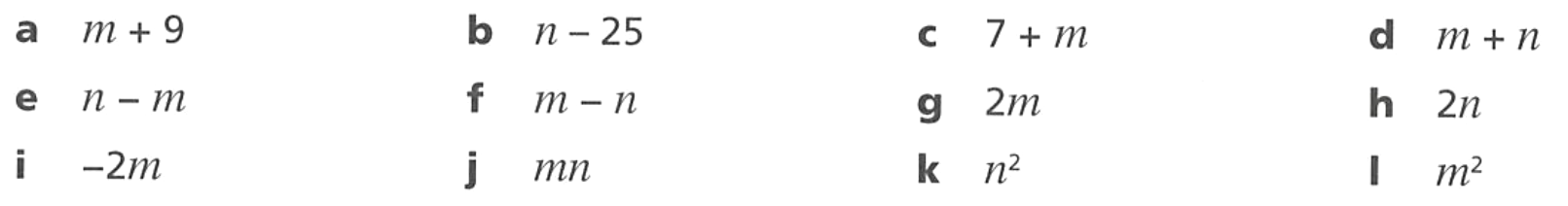  $-5$ | 3 | 16
24 | $-24$ | $-8$ | 40
8 | $-80$ | 400 | 16

- If $p=4$, $q=-3$, $r=5$, work out the value of:
$-27$ | 3 | 25 | $-4$

- $f=-3$, $g=-10$, $h=9$. Find the value of:
3 | 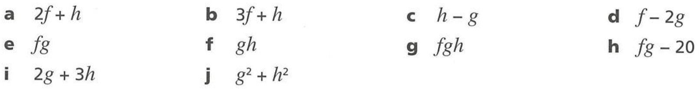  0 | 19 | 17
30 | $-90$ | 270 | 10

- For $m=3$ and $n=7$, find the value of:
- $\sqrt{6m+n}$  5 | - $\sqrt{10\left(m+n\right)}$  10 | - $\sqrt{4\left(n-m\right)}$  4 | - $\sqrt{7m+4n}$  7
- For $x=3$ ,$y=$ $\frac{1}{2}$, $z=-5$ evaluate these expressions.
- $x+4$  7  - $x-4$  $-1$  - $4x$  12  - $4x+y$  12.5  - $4x+2y$  13  - $4x-2y$  11  - $2y-4x$  $-11$  - $2y+z$  $-4$  - $3x+z$  4  - $3x-z$  14 | - $-2z$  10  - $-2z-x$  7  - $-2z-x-y$  6.5  - $2\left(-2z-x-y\right)$  13  - $2\left(2z+x+y\right)$  -13  - $2x+x+y$  9.5  - $\frac{2x+x+y}{2}$  4.75  - $\frac{y+x+2z}{2}$  $-3.25$  - $\frac{y+x-2z}{2}$  $6.75$  - $y+x-\left(\frac{2z}{2}\right)$  $8.5$

- Evaluate these expressions by substituting $a=-2$, $b=6$, $c=-3$
a $a^{2}-b$  $-2$ | b $a-b^{2}$  $-38$ | c $2c+a$  $-8$
d $b^{2}-c^{2}$  27 | e $a^{3}+c^{2}$  1 | f $3ab+ac$  $-30$
g $c-2ab$  $21$ | h $abc-{\left(ac\right)}^{2}$  0 | i $c(a+b)$  $-12$

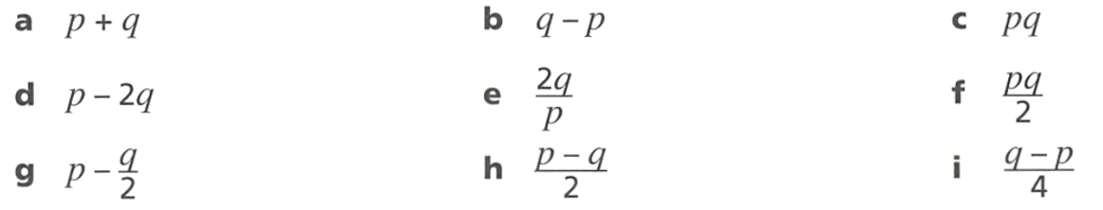
Mastery
- $p=8$ and $q=-12$. Work out
$-4$ | $-20$ | $-96$
32 | $-3$ | $-48$
14 | 10 | $-5$

- 2008 HSC Standard 2 Band 4
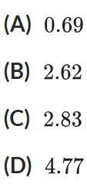
What is the value of $\sqrt{\frac{x+2y}{8y}}$ if $x=5.6$ and $y=3.1$, correct to 2 decimal places?

A
- HSC Standard 2 Sample Question Band 4
What is the value of $\frac{a+b}{ab}$ if $a=-2.1$ and $b=-3.6$, correct to 1 decimal place?

$-0.8$
- 2010 HSC Standard 2 Band 5
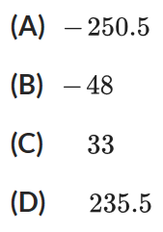
If $M=-9$, what is the value of $\frac{3M^{2}+5M}{6}$?

C
- Evaluate $8p-$ $\frac{14}{q}$ when $p=$ $\frac{-3}{8}$, $q=-7$

$-1$

- Complete the table.
$$x$$ | 3 | 1 | 0.25 | $$-2$$ | 2 | $$\frac{8}{7}$$
$$4x+2$$ | 14 | 6 | 3 | $-6$ | 10 | $$\frac{46}{7}$$
$$4-3x$$ | $$-5$$ | 1 | 3.25 | 10 | $$-2$$ | $$\frac{4}{7}$$
$$2x-4$$ | 2 | $$-2$$ | $$-3.5$$ | $$-8$$ | 0 | $$-\frac{12}{7}$$

- Complete the table.
$$a$$ | 5 | 8 | 2 | 3 | $$-20$$ | 10
$$b$$ | 2 | 2 | 1 | 7 | 10 | $-3$
$$a+b$$ | 7 | 10 | 3 | 10 | $-10$ | 7
$$a+2b$$ | 9 | 12 | 4 | 17 | 0 | 4
$$a-b$$ | 3 | 6 | 1 | $-4$ | $-30$ | 13

Generating Patterns by Substitution

- Consecutive Numbers Create Patterns
Substituting consecutive numbers into an expression can make a number pattern.

- Example Generate a number pattern by substitution
$$x$$ | 0 | 1 | 2 | 3 | 4 | 5 |  | 10 |  | 100 | Change by 1,  starting at 3
$$x+3$$ | 3 | 4 | 5 | 6 | 7 | 8 |  | 13 |  | 103 | Change by 1,  starting at 3

$$x$$ | 0 | 1 | 2 | 3 | 4 | 5 |  | 10 |  | 100 | Change by 2,  starting at $-1$
$$2x-1$$ | $$-1$$ | 1 | 3 | 5 | 7 | 9 |  | 19 |  | 199 | Change by 2,  starting at $-1$

- Guided Practice
Complete these tables to generate a number pattern from the algebraic expression.
$$x$$ | 0 | 1 | 2 | 3 | 4 | 5 |  | 10 |  | 100 | Change by ………  Starting at ………
$$2x$$ |  |  |  |  |  |  |  |  |  |  | Change by ………  Starting at ………

0 2 4 6 8 10 20 200; change by 2 starting at 0
$$x$$ | 0 | 1 | 2 | 3 | 4 | 5 |  | 10 |  | 100 | Change by ………  Starting at ………
$$2x+3$$ |  |  |  |  |  |  |  |  |  |  | Change by ………  Starting at ………

3 5 7 9 11 13 23 203 change by 2 starting at 3
$$x$$ | 0 | 1 | 2 | 3 | 4 | 5 |  | 10 |  | 100 | Change by ………  Starting at ………
$$5x-7$$ |  |  |  |  |  |  |  |  |  |  | Change by ………  Starting at ………

$-7$ $-2$ 3 8 13 18 43 493 change by 5 starting at $-7$
$$x$$ | 0 | 1 | 2 | 3 | 4 | 5 |  | 10 |  | 100 | Change by ………  Starting at ………
$$-4x$$ |  |  |  |  |  |  |  |  |  |  | Change by ………  Starting at ………

0 $-4$ $-8$ $-12$ $-16$ $-20$ $-40$ $-400$ change by $-4$ starting at 0

- Key Ideas
- By substituting ……………………… numbers, we can form a number pattern.

Foundation
- Complete these tables to generate a number pattern from the algebraic expression.
$$x$$ | 0 | 1 | 2 | 3 | 4 | 5 |  | 10 |  | 100 | Change by ………  Starting at ………
$$3x$$ |  |  |  |  |  |  |  |  |  |  | Change by ………  Starting at ………

0 3 6 9 12 15 30 300 change by 3 starting at 0
$$x$$ | 0 | 1 | 2 | 3 | 4 | 5 |  | 10 |  | 100 | Change by ………  Starting at ………
$$3x+1$$ |  |  |  |  |  |  |  |  |  |  | Change by ………  Starting at ………

1 4 7 10 13 16 31 301 change by 3 starting at 1
$$x$$ | 0 | 1 | 2 | 3 | 4 | 5 |  | 10 |  | 100 | Change by ………  Starting at ………
$$3x+2$$ |  |  |  |  |  |  |  |  |  |  | Change by ………  Starting at ………

2 5 8 11 14 17 32 302 change by 3 starting at 2
$$x$$ | 0 | 1 | 2 | 3 | 4 | 5 |  | 10 |  | 100 | Change by ………  Starting at ………
$$2+3x$$ |  |  |  |  |  |  |  |  |  |  | Change by ………  Starting at ………

2 5 8 11 14 17 32 302 change by 3 starting at 2
$$x$$ | 0 | 1 | 2 | 3 | 4 | 5 |  | 10 |  | 100 | Change by ………  Starting at ………
$$-3x+2$$ |  |  |  |  |  |  |  |  |  |  | Change by ………  Starting at ………

2 $-1$ $-4$ $-7$ $-10$ $-13$ $-28$ $-298$ change by $-3$ starting at 2
$$x$$ | 0 | 1 | 2 | 3 | 4 | 5 |  | 10 |  | 100 | Change by ………  Starting at ………
$$2-3x$$ |  |  |  |  |  |  |  |  |  |  | Change by ………  Starting at ………

2 $-1$ $-4$ $-7$ $-10$ $-13$ $-28$ $-298$ change by $-3$ starting at 2
$$x$$ | 0 | 1 | 2 | 3 | 4 | 5 |  | 10 |  | 100 | Change by ………  Starting at ………
$$-2x+2$$ |  |  |  |  |  |  |  |  |  |  | Change by ………  Starting at ………

0 $-2$ $-4$ $-6$ $-8$ $-18$ $-198$ change by $-2$ start at 2
$$x$$ | 0 | 1 | 2 | 3 | 4 | 5 |  | 10 |  | 100 | Change by ………  Starting at ………
$$-x-2$$ |  |  |  |  |  |  |  |  |  |  | Change by ………  Starting at ………

$-2$ $-3$ $-4$ $-5$ $-6$ $-7$ $-12$ $-102$ change by $-1$ starting at $-2$
$$x$$ | 0 | 1 | 2 | 3 | 4 | 5 |  | 10 |  | 100 | Change by ………  Starting at ………
$$-x+1$$ |  |  |  |  |  |  |  |  |  |  | Change by ………  Starting at ………

1 0 $-1$ $-2$ $-3$ $-4$ $-9$ $-99$ change by $-1$ starting at 1
$$x$$ | 0 | 1 | 2 | 3 | 4 | 5 |  | 10 |  | 100 | Change by ………  Starting at ………
$$1-x$$ |  |  |  |  |  |  |  |  |  |  | Change by ………  Starting at ………

1 0 $-1$ $-2$ $-3$ $-4$ $-9$ $-99$ change by $-1$ starting at 1
$$x$$ | 0 | 1 | 2 | 3 | 4 | 5 |  | 10 |  | 100 | Change by ………  Starting at ………
$$-x$$ |  |  |  |  |  |  |  |  |  |  | Change by ………  Starting at ………

0 $-1$ $-2$ $-3$ $-4$ $-5$ $-10$ $-100$ change by $-1$ starting at 0
$$x$$ | 0 | 1 | 2 | 3 | 4 | 5 |  | 10 |  | 100 | Change by ………  Starting at ………
$$3x-5$$ |  |  |  |  |  |  |  |  |  |  | Change by ………  Starting at ………

$-5$ $-2$ 1 4 7 10 $25$ $295$ change by 3 starting at $-5$

Development
- By looking at the questions in Q1, complete the sentences:
In the expression $mx+c$: the coefficient of $x$ is ………… and the constant term is …………
The coefficient of $x$ represents how much to change as you increase $x$ by ………
The constant term represents the number to ………… at, i.e., when $x=0$

- Determine the number pattern formed by these equations.
- $3x+6$  Change by 3  Starting at 6 | - $3x+9$  Change by ……………  Starting at ……………  Change by 3 starting at 9 | - $6x+18$  Change by ……………  Starting at ……………  Change by 6 starting at 18
- $3x+18$  Change by ……………  Starting at ……………  Change by 3 starting at 18 | - $3x-18$  Change by ……………  Starting at ……………  Change by 3 starting at $-18$ | - $2x-18$  Change by ……………  Starting at ……………  Change by 2 starting at $-18$
- $18-2x$  Change by ……………  Starting at ……………  Change by $-2$ starting at 18 | - $-2x+18$  Change by ……………  Starting at ……………  Change by $-2$ starting at 18 | - $-4x+18$  Change by ……………  Starting at ……………  Change by $-4$ starting at 18
- $-4x-18$  Change by ……………  Starting at ……………  Change by $-4$ starting at $-18$ | - $4x-18$  Change by ……………  Starting at ……………  Change by 4 starting at $-18$ | - $-5.4-$ $\frac{9}{4}$ $x$  Change by ……………  Starting at ……………  Change by $-\frac{9}{4}$ starting at $-5.4$

